Mark Zuckerberg Biography

Mark Zuckerberg is a computer programmer and entrepreneur, famous for his website, ‘Facebook’. This biography provides detailed information about his childhood, profile, career and timeline

 | Quick Facts
Also Known As |  | Mark Elliot Zuckerberg
Famous as |  | Co-founder of Facebook, Computer Programmer
Nationality |  | American
Religion |  | Atheism
Born on |  | 14 May 1984 AD
Height |  | 1.71 m
Zodiac Sign |  | Taurus
Born in |  | White Plains
Father |  | Edward Zuckerberg
Mother |  | Karen Kempner
Siblings |  | Donna Zuckerberg, Randi Zuckerberg, Arielle
 |  | Zuckerberg
Spouse |  | Priscilla Chan
Education |  | 2000 - Ardsley High School, 2002 - Phillips Exeter
 |  | Academy, Mercy College, Harvard University
Founder/Co-Founder |  | Facebook, Inc., ConnectU, FWD.us
Net worth |  | $65.5 billion in May 2017
Awards |  | Time's Person of the Year
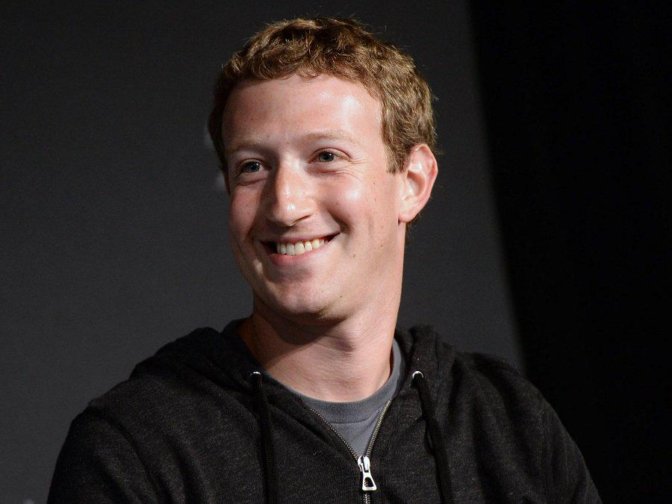

www.thefamouspeople.com Page 1 / 6
Mark Zuckerberg is famous worldwide, for having developed 'Facebook', the most widely used social networking website. At a very young age, he was taught how to write computer programs by his father, and tutor David Newman. In high school, he developed a music player, 'Synapse', and while still a student at 'Harvard University', he launched his website 'Facebook', along with college mates Chris Hughes, Eduardo Saverin, Andrew McCollum, and Dustin Moskovitz. Though he was initially accused by some senior students, of having stolen their idea, his site's popularity was not affected. 'Facebook' saw a steady rise in the number of active users per month. The founder kept adding to the platform with services like 'Wirehog', 'Beacon' and 'Connect'. The website started out as a networking platform only for 'Harvard University', and then was opened for other colleges. Soon, it became available to general public, and gained widespread popularity for its user-friendly interface. Zuckerberg is now the chairman and CEO of the company 'Facebook, Inc', earning one dollar as his salary. His website has made him so popular that the film ‘The Social Network’, starring Jesse Eisenberg, was made based on a book, ‘The Accidental Billionaires’, which documented Mark’s life

Childhood & Early Life:

Mark Elliot Zuckerberg was born to Edward, and his wife Karen, in the city of White Plains, New York, on May 14, 1984. Edward was a dentist, while Karen worked as a psychiatrist. The young boy was brought up in the village of Dobbs Ferry, along with siblings Randi, Arielle, and Donna.

He pursued his education from the 'Ardsley High School', New York, and later the 'Phillips Exeter Academy' in New Hampshire, where he exhibited flair for astronomy, mathematics, physics, English classical literature, foreign languages. He was also asked to lead the fencing team of the 'Phillips Exeter Academy'.

While in middle school, Mark was taught 'Atari BASIC Programming' by his father in the 1990s. Eventually software programmer David Newman began teaching the young boy everything about programming.

The talented young child was in high school when he enrolled with 'Mercy College', to pursue a course in software programming. During this time, he developed a software called 'ZuckNet' to create a communication network between the computers in his father's dental office and those at home.

Around the same time, he made a music player that was programmed to memorize a listener's music choices. The programme, named 'Synapse Media Player', was built under the banner of a company called 'Intelligent Media Group', and was posted to a news website, 'Slashdot'.

Career:

The budding software developer began attending the 'Harvard University', majoring in psychology and computer science. During his days at the university, he built programmes titled

www.thefamouspeople.com Page 2 / 6
'CourseMatch' and 'Facemash'. While 'CourseMatch' helped students select their courses and decide on study groups, 'FaceMash' was meant for fun, allowing students to choose the best face among a selection of photos.

In the next semester, in 2004, Mark launched a new website called 'Thefacebook.com'. He created the social networking site that along with friends Chris Hughes, Eduardo Saverin, Andrew McCollum, and Dustin Moskovitz.

He was accused of having stolen the ideas of senior students, Divya Narendra, and twins Cameron and Tyler Winklevoss, who had planned on a social media site called ‘The Harvard Connection’. As a settlement to the lawsuit, Zuckerberg had to give the three seniors Facebook shares worth 300 million dollars.

Soon, Zuckerberg quit college, and began working on his site in a new office at Palo Alto, California. In 2004, along with his friends, he introduced 'Wirehog', a file sharing program, as a competition to fellow Harvard student, Wayne Chang's 'i2hub'.

In 2005, 'Accel Partners', a company dealing in growth equities, funded 'Facebook' with 12.7 million dollars. Two years later, Mark launched 'Facebook Platform' to enable software developers to use 'Facebook' to build other applications.

Within the next year, this brilliant software programmer introduced two other services within the 'Facebook' platform, called 'Beacon' and 'Connect'.

'Facebook' was initially meant for students of 'Harvard University', but was later distributed to other educational institutions including 'Yale', 'Dartmouth', 'Stanford' and 'Columbia'.

Zuckerberg introduced a new project in 2013, titled 'Internet.org', in collaboration with cell phone firms like ‘Qualcomm’, ‘Samsung’, ‘Opera Software’, ‘Ericsson’, ‘Microsoft’, ‘MediaTek’, and ‘Reliance’. The aim of the project was to enable widespread use of Internet in developing countries.

The same year, this software developer became the CEO and Chairman of the company ‘Facebook, Inc.’, and was offered one dollar as salary.

Major Works:

Zuckerberg shot to fame with his social networking site called ‘Facebook’, which started out as a connecting platform for students of ‘Harvard University’. Having reached out widely to the public, the site currently has 1.44 billion monthly users.

Awards & Achievements:

In 2010, this accomplished entrepreneur was named the 'Person of the Year', by 'Times' magazine.

In 2011, 'The Jerusalem Post', an Israeli newspaper, named him the one of the 'Most Influential Jews'.

www.thefamouspeople.com Page 3 / 6
Personal Life & Legacy:

Mark started dating Priscilla Chan, a fellow student at 'Harvard University', while he was still in college. After seven years, they began living together, in a rented accommodation in Palo Alto.

In 2009, writer Ben Mezrich released a book titled 'The Accidental Billionaires', based on the famous entrepreneur's life. Mezrich sold the rights to Aaron Sorkin, who wrote the screenplay for the movie 'The Social Network'. Mark claimed that the film was a deviation from the story of his life.

In 2010, he established a 'Start-up: Education foundation', which aims at improving the quality of education provided in public schools.

Zuckerberg and Priscilla got married on May 19, 2012. The couple had a daughter named Max in 2015.

This famous entrepreneur contributes regularly to social causes, and has made monetary donations to the ‘Newark Public Schools’, and ‘San Francisco General Hospital’. Along with his wife, he also contributed $25 million to help victims of the Ebola disease in West Africa.

Net Worth:

This successful entrepreneur has a net worth of 36 billion dollars, and has regularly featured on the ‘Forbes 400’ list.

Trivia:

This brilliant software developer has faced several lawsuits for rights to his revolutionary social networking website, including one from the site’s co-founder

On Dec 1, 2015, Mark Zuckerberg announced that he and his wife would give 99 percent of their Facebook shares “during our lives” to charitable purposes.

Quotes By Mark Zuckerberg

www.thefamouspeople.com Page 4 / 6
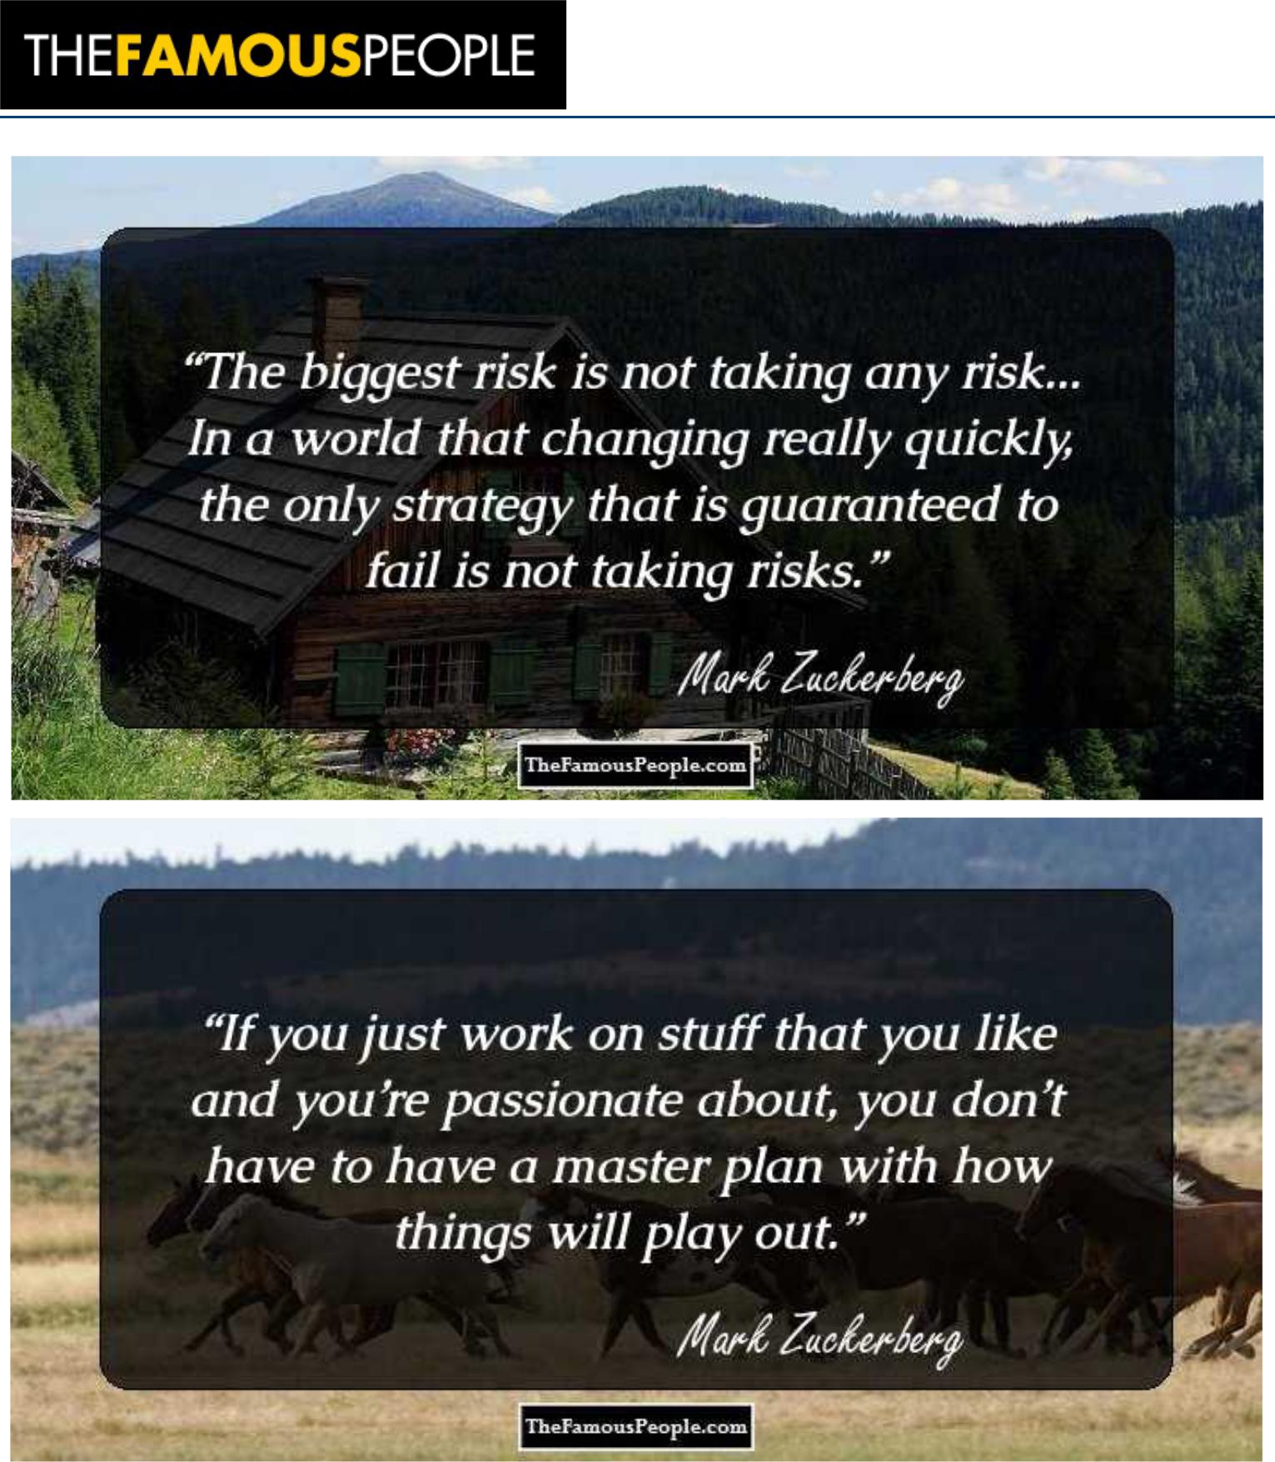

www.thefamouspeople.com Page 5 / 6
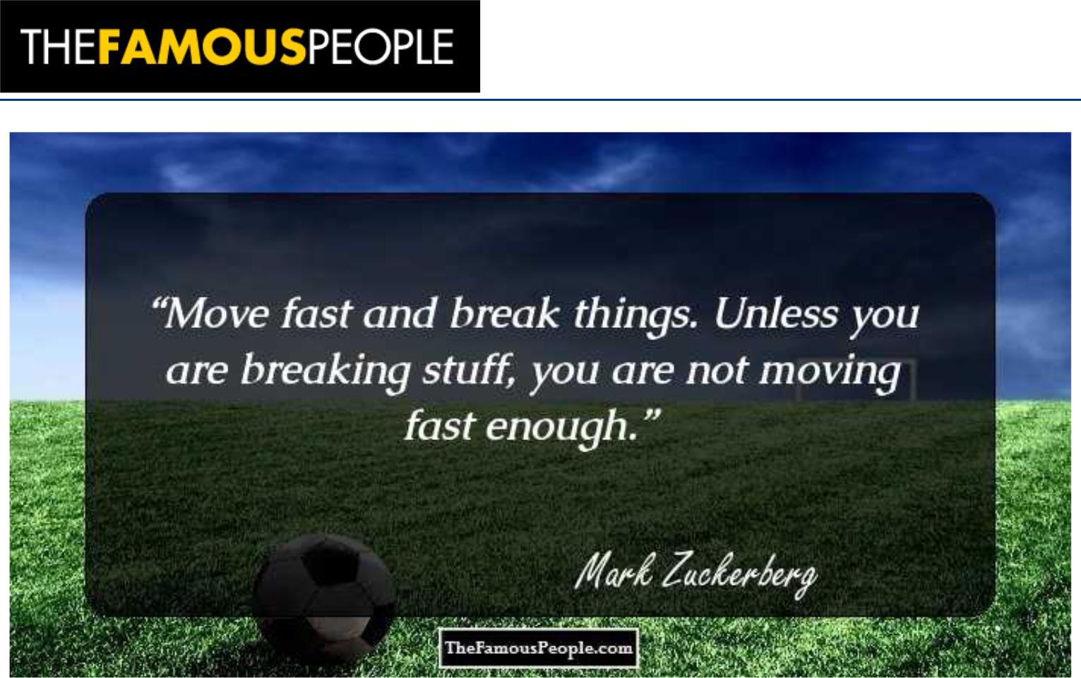

www.thefamouspeople.com Page 6 / 6

Powered by TCPDF (www.tcpdf.org)

